English GCSE
Speaking and Listening

Name:
Give an ENTERTAINING speech to the class. Be prepared to answer a variety of questions as part of your assessment. Your assessment will be filmed to send off to the exam board in Year 11. Your presentation will need to last 3-4 minutes. Questions will need to last approximately 5 mins

Task:

How will you be assessed?
AO7 | Demonstrate presentation skills in a formal setting
AO8 | Listen and respond appropriately to spoken language, including to questions and feedback to presentations
AO9 | Use spoken Standard English effectively in speeches and presentations.
Pass | Merit | Distinction
· expresses straightforward/ideas information/feelings,  · makes an attempt to organise and structure his or her presentation,  · makes an attempt to meet the needs of the audience, and  · listens to questions/feedback and provides an appropriate response in a straightforward manner | · expresses challenging ideas/information/ feelings using a range of vocabulary,  · organises and structures his or her presentation clearly and appropriately to meet the need of the audience,  · achieves the purpose of his or her presentation, and  · listens to questions/feedback responding formally and in some detail. | · expresses sophisticated  ideas/information feelings  using a sophisticated repertoire  of vocabulary,  · organises and structures  his or her presentation using an  effective range of strategies to  engage the audience,  · achieves the purpose of his or  her presentation and  · listens to questions/feedback,  responds perceptively and if  appropriate elaborates with  further ideas and information

Teacher comment:

Grade F/P/M/D

Watch examples of a variety of speeches online and make notes in the table below:

Focus | Your Comments
How was the speech structured?

(Include a brief outline)

How effective was this structuring?
How did this person approach their topic in an original/interesting way?

List all the techniques used in the presentation:

How effectively did they use these techniques?
Did the person use sophisticated vocabulary?

In terms of tone and use of voice, how interesting was the presentation for you, the audience?

Using the notes above, create a checklist for your speaking and listening assessment. What do you need to do to ensure your presentation is effective?

1.
2.
3.
4.
5.
6.
7.
8.

Select one of the images below. You have 15 mins to produce a 1 minute speech about the image as if you are reporting the news.

Aim:

- Use your imagination, don’t just tell us what is there or what is obvious
- Consider whether you can use humour to make your report interesting
- Think about your tone of voice; vary it to make your report interesting
- Fluency – make sure you rehearse what you are going to say to ensure you are fluent





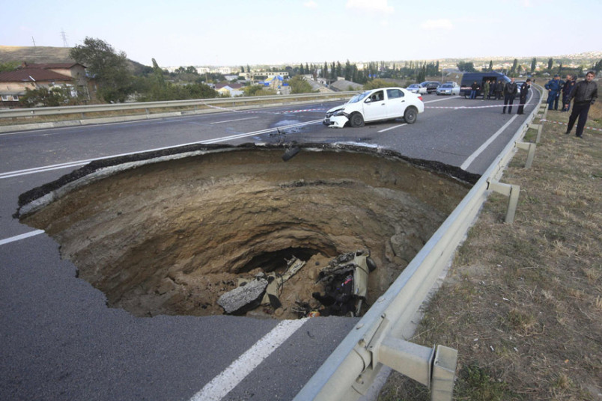

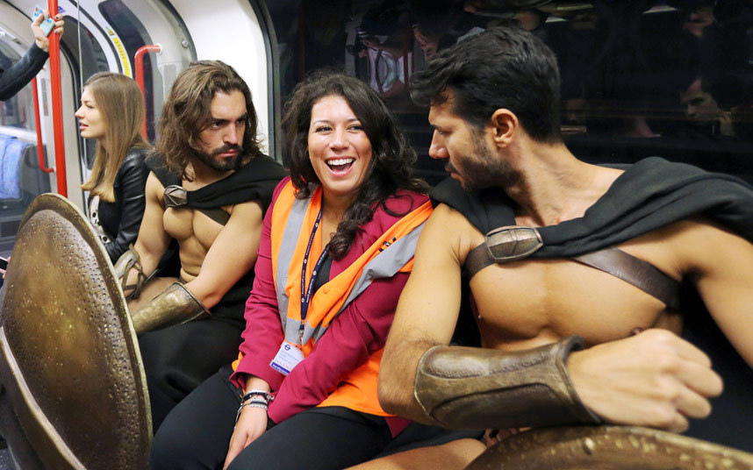



Present your report to someone else in your house. How do you think you did?
Pass | Merit | Distinction
· expresses straightforward/ideas information/feelings,  · makes an attempt to organise and structure his or her presentation,  · makes an attempt to meet the needs of the audience, and  · listens to questions/feedback and provides an appropriate response in a straightforward manner | · expresses challenging ideas/information/ feelings using a range of vocabulary,  · organises and structures his or her presentation clearly and appropriately to meet the need of the audience,  · achieves the purpose of his or her presentation, and  · listens to questions/feedback responding formally and in some detail. | · expresses sophisticated  ideas/information feelings  using a sophisticated repertoire  of vocabulary,  · organises and structures  his or her presentation using an  effective range of strategies to  engage the audience,  · achieves the purpose of his or  her presentation and  · listens to questions/feedback,  responds perceptively and if  appropriate elaborates with  further ideas and information

Student feedback:
How can you improve your performance?

Ja Ja Binks’ Flappy Ears

Ears. We all have them, sometimes we use them. And sometimes we wonder how those little, flappy pieces of meat got stuck to the sides of our heads. I am here today, to tell you the origins of the enigma that is the ear, to discuss the issues that arise from owning such precarious appendages, and, most of all, to pay homage to the owner of the flappiest of all the ears, Mr. Ja Ja Binks.

Ears originated around 720 BC in Argos. It is thought that the tribes that lived there had mere holes in the sides of their heads for the first 1000 years of their existence. During the summer of 719BC, the tribe, the Binkeses, were plagued by swarms of bees. They were friendly bees but had a cheeky edge to them. They used to hide nuggets of honey in the Binkses ear holes whilst they were asleep. At first, this only caused mere discomfort for the Binkses, but as time went on, more and more bees kept stuffing more and more honey into their Bink-holes. Eventually all the Binkses heads began to swell until one fateful afternoon, Hoo Ha Binks’ head exploded. ‘Enough’ thought the chief, Wee Wee Binks, and he decided that something should be done. From that day forward all the Binkses began stapling leaves to the sides of their heads, in the hope that the flaps would protect them. It worked, the trend spread, and now everyone’s got ‘em.

Not fish though.

You don’t get bees underwater so there’s no need.

And so, my fellow ear mongers, it is here that I must steer my speech in a new direction…….in the direction of YOU.

Each one of you has at least one ear and I bet you rarely ever take the chance to wonder at the beauty of that ear. I want you to take the time now to focus all your attention on those lovely ears. Why is it that that ear is such a weird shape? Why are they at the sides of our head and not on top? Why can some people wiggle their ears and others can’t? But for all the mystery that shrouds the human ear, one thing is certain:

What use is the human ear in protecting us from pesky bees?

Sure, the shape of our ears will let us know when a bee is near. But will it ever stop them?!

The answer my friends, is no.

And so I move to the purpose of my speech, the real reason that I have come to talk to you all today.

Humans need ear flaps.

Only an ear flap will protect us against those stripy mongrels and their sticky, sickly, sinister hoards of gloop. Only an ear flap can save us from that violent torment that is shoving a truckload of honey into pinprick of a hole, that torment so sneakily induced by those buzzing, bumbly bees! Move over Honey Monster – there’s a new bad ass in town!

Can the governments of the world really expect us to carry on risking our lives every time we go to sleep? To hell they can’t!!!

So, brothers and sisters of vulnerable ears, join with me now....Want do we want? EAR FLAPS, When do we want them? NOW!

Task:

Consider how you would perform this speech? Spend 10 minutes reading this speech and deciding:

- Where and how you will change your tone of voice
- Your body language at various points of the speech
- Any ideas/words/phrases you think should be emphasized

Prepare a performance of the speech.

Based on your performance judge where you are according to the assessment criteria:

Pass | Merit | Distinction
· expresses straightforward/ideas information/feelings,  · makes an attempt to organise and structure his or her presentation,  · makes an attempt to meet the needs of the audience, and  · listens to questions/feedback and provides an appropriate response in a straightforward manner | · expresses challenging ideas/information/ feelings using a range of vocabulary,  · organises and structures his or her presentation clearly and appropriately to meet the need of the audience,  · achieves the purpose of his or her presentation, and  · listens to questions/feedback responding formally and in some detail. | · expresses sophisticated  ideas/information feelings  using a sophisticated repertoire  of vocabulary,  · organises and structures  his or her presentation using an  effective range of strategies to  engage the audience,  · achieves the purpose of his or  her presentation and  · listens to questions/feedback,  responds perceptively and if  appropriate elaborates with  further ideas and information

Student feedback:
What do you need to do to achieve the next grade?

Use this page to start planning your topic.

Mind map everything that comes to mind about that topic. Don’t just include the obvious- try to think outside the box. (You might want to plan more than one topic at this stage).

Consider:

- What FEELINGS/ATTITUDES are linked to your topic?
- Do you have any PERSONAL experiences or stories
linked to your topic?
- Are there any current stories in the news linked to
your topic?
- What are the Pros and Cons of the topic title?

You now have to prepare your speaking and listening assessment.

Remember, you can’t read your presentation – you must perform it.

Notes

Use the table below to record any observations about your speech as you prepare/rehearse it

Focus | Your Comments
How was the speech structured?

(Include a brief outline)

How effective was this structuring?
How did this person approach their topic in an original/interesting way?

List all the techniques used in the presentation:

How effectively did they use these techniques?
Did the person use sophisticated vocabulary?

In terms of tone and use of voice, how interesting was the presentation for you, the audience?

Focus | Your Comments
How was the speech structured?

(Include a brief outline)

How effective was this structuring?
How did this person approach their topic in an original/interesting way?

List all the techniques used in the presentation:

How effectively did they use these techniques?
Did the person use sophisticated vocabulary?

In terms of tone and use of voice, how interesting was the presentation for you, the audience?

Focus | Your Comments
How was the speech structured?

(Include a brief outline)

How effective was this structuring?
How did this person approach their topic in an original/interesting way?

List all the techniques used in the presentation:

How effectively did they use these techniques?
Did the person use sophisticated vocabulary?

In terms of tone and use of voice, how interesting was the presentation for you, the audience?

